Off the grid power system options

Abstract
The current renewal of the calls for the nations of the world to go green, the off the grid connections systems have taken a lead in the productions of the green energy. The paper is going to produce a findings on how a house that is off the grind can be connected to a comprehensive power supply system that is reliable and does not disappoint. The power exploits how the house can be connected to the solar system, wind power, secondary system and the fuel generator so that the three systems can work interdependently. The paper will try to exploit some of the technologies in the market and recommend the best technology that can be implemented for the off the grid technology powering system in this case

Introduction
Energy is significant in the current world that we are living. Initially, power was seen as something that was more required for industrial purposes that domestic purposes. However, with the current increased standard of living and the change of lifestyle to modernity, the local uses of power have indeed become more dynamic from the traditional method of energy for night vision in the houses. In the modern home, there are very many gadgets that families utilise that require power to be operated. Such items such as the food preservers (fridges, coolers, and water dispensers), electronics (television, radio, computing accessories and phones) heat regulators (Air conditions and water heaters) and other kitchen apparatus that require energy to be used. For any house that is off the national grid, it becomes apparent that there is a need to come up with an elaborate power system that will provide these needs and still be dependable or perhaps more dependable than the national power grid supply.
The research conducted here is going to give the power system of the house that is off the national grid that has an average 3000 watts and the peak power usage of 10000 watts. These house power system will be supplied with four different technologies namely the solar cells array, the wind power system, fuel system and the battery sales. The four systems will produce energy that will be converted into by the required version of the DC by the use of converter the converter will be turning the DC in either
• 120VAC at max current of 60 amps.
• 220VAC with a max current of 20 amps.
• A maximum power output of 10,000
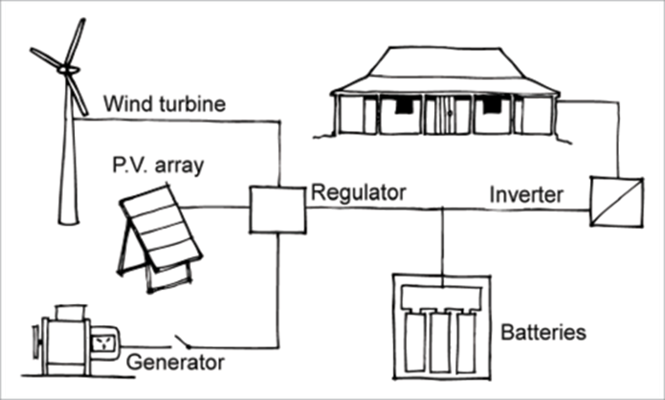
Figure 1: The figure of the house connected to four power systems
Solar Cells arrays
The solar cell array that will be used in this system will consist of 40 solar panels to have the ability to provide the energy supply that is needed for this home system. The solar array will be made up of 40 solar panels with each solar group having the ability to produce 250 watts which will lead to a total solar panel production of 10,000watts. The solar array will be converted into a Photovoltaic system by including the balance of system components. The balance of system components are the components that are required to safely turn the DC into the AC that is needed for the home appliances for the home appliances to work effectively(Maehlum,2018). The balance of system components that will be required in this home system will consist of; Inverters, Power-conditioning equipment, Safety equipment, Instrumentation, Meters
Inverters
The inverters will be necessary to convert the DC energy that will be produced by the home solar system array into an AC. Some very inverters technologies can be used in this solar technology. There are currently three types of solar inverters technology that are now in the market namely the micro inverters the optimizers and the string inverter (also known as centralized) inverters.
For this home supply system, the string inverters will be the most cost-effective inverters system that will be installed. Most companies a solar technology with a string inverter system. However, the string inverter system is best used in a house with a roof that is not shaded at any point during the day and does not face in multiple directions (such as a gabled roof). The solar panels will be arranged into groups that are connected the strings. Therefore, each line will be connected to a single inverter which will transform the DC electricity produced by the panels into a much appliance friendly AC electricity.

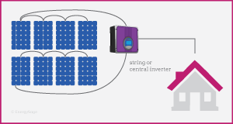
Figure 2: Showing how a string inverter works
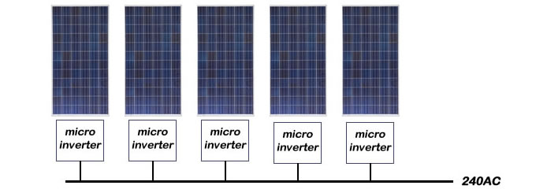
Figure: The figure showing how the micro inverters are installed
The string inverter technology is the best technology for this house because it has been used for an extended period by many households and it is easily understandable. Another reason why the string inverter is the technology that was chosen for this household is that it can be said to be a tried and true technology. Another reason why the string inverter is the recommended technology for this house project is that the roof, the place where the solar panels will be installed will be facing one direction faces one direction, hence the cases of shading which may reduce the output of the solar system connected by the string inverters may not arise.
The solar system of the house will be shielded from the elements of the shading from the nearby objects which may make the system to start producing very little energy than it was estimated. Hence the solar panel for the house will be installed in areas where there are very minimal chances of shading appearing.
The merits of the string inverters
The string inverters are found to be the most familiar type of solar inverters that have been around for many years. The success of the string inverters can be associated closely with their durability and their success and the fact that they were there when there was no other alternatives in the market. Another merit that has been credit to the use of the string inverters is the fact that they have been associated with the ease maintenance compared to other forms of inverters. Most of the string inverters are usually installed in the common room and are in most cases usually mounted on the wall. The kind of installation has been found to have the chance of facilitating the ease of maintenance since there is no need for one to go back and forth in the field in the name of maintenance and trouble shooting. These benefits becomes extremely significant in regions that have extremely hot or cold weathers. Another merit that can be associated with string inverters is the fact that the technology that was used to construct the string inverters is a trusted technology compared to the others emerging technology that have been used to construct the current bunch of inverters that are entering the market. These merit has made this technology to be understood by many electricians compared to other technologies. Therefore, there are higher chances that the electrician installing a solar might recommend the string inverter. When it comes to the costs, string inverters are currently cheaper than micro inverters. You only need one string inverter per installation, while for micro inverters, one would need one inverter per panel.
The demerits of string inverters
The string inverters also have the demerits that is associated with them. The have the single point failure characteristics such that when an inverter break down the whole solar system becomes rendered inoperable. These characteristics can lead to significant loss to electricity production when it happens. Another demerit that has been associated with the solar system is the expandability. The expandability of the string inverter is usually restricted as installed for a certain rating as the inverter rating cannot be altered

System monitoring: voltmeters, ammeters, A-H counters, and power meters
The home system will require the solar panel meters that are very imperative for the tracking of the solar systems to perform fault isolation and rectification. The house will use the voltmeter for the voltage measurement and an ammeter that will be for current measurement.
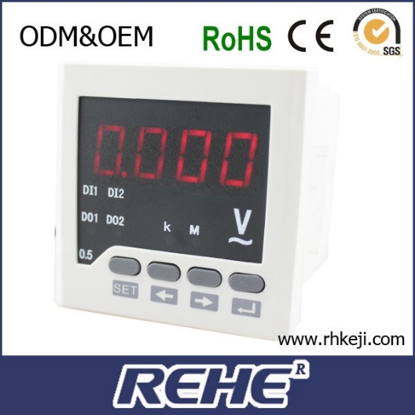
Figure 3: Picture of recommended Rehe- digital voltmeter

The Rehe digital voltmeter will be used in this project to measure the voltage of the and the Rehe ammeter alternatively the project can use the Dossy ammeter and voltmeter which combine both the functions to save the money that will have been used for the purchase of the two different instruments for the system. The current capability of the will be according to the capacity of the installation. The Dc meters voltage can go up to the high of 30 Volts, and the meters will be fixed in the case of this home power supply system
Other balance of checks systems
The system may also require the clamp meters for measuring the current without the real action of breaking the circuit. A-H the current will keep the record of how much battery capacity has been utilized and how much balance could be expected in the system
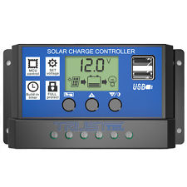
Figure 4:The solar controller
The balance of systems equipment is very imperative for the house powered by the solar panel whether it is off the grid or on the network. They enable the solar system to condition the electricity and transmit the electricity to the load that will be used and store the excess power for the future usage. Since the house system is off the grind, otherwise known as the standalone system, the amount of the equipment that will be needed will depend on what the system will be required to do. In a simple system, the energy that was being generated in this system could have been connected directly to the load that is being powered. However, for the case of this house, the energy will be taken first to the power storage facilities before it is directed to the load. Therefore another thing that will be required in this case will be a battery charge and a charge controller. The recommended battery charge for this system will be Morningstar Tristar MPPT with an optional digital display 9V-125V input and 45 A max and at 24VDC.
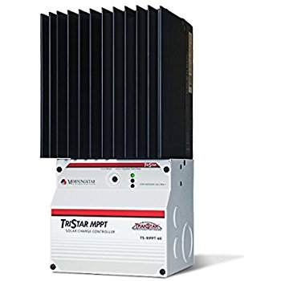
Figure 5: Recommended battery charge the morning star Tri-Star MPPT with digital display 9V-125V input and 45 A max and at 24VDC
There are other balances of checks system that could require the different home solar system and not required in another. However, in totality, the balance of check system will have the will in most cases account for the half of the total cost of the system installation. There are different equipment's that will be rewarded for the balance of checks system, but a typical balance of check system will require charge controllers, batteries, power condition equipment, meters and instrumentation and safety equipment
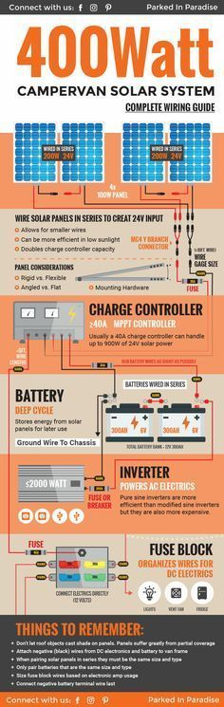
Figure 6: The following infographics gives a guidelines of the balance of the checks system that may be required in any home solar system. The requirements of the components may change depending on the watts
Wind power system
When it comes to the wind power system, there are two choices to choose from namely the horizontal wind power system and the axis power system. The horizontal wind power turbines typically have two or three blades. The three-blended wind turbines are usually operated upwind with the edges facing into the winds. For this house power system, the wind power system that will be used will be the horizontal wind power system. Another important thing about the wind power system is because it can be built on land or offshore in large water bodies like oceans and lakes. The power system for this house will be on land.
Sizes of Wind Turbines
The utility-scale turbines usually range from 100 kilowatts to as large as several hundred megawatts. In most cases, giant wind turbines are generally cost effective and in most cases are usually fixed together into wind farms which in most cases are usually used for the provision of power for the grids. Offshore wind turbines in most cases are also massive in most cases and can generate more electricity, and in most cases, they will not be accompanied with the transportation challenges of land-based wind installations as in most cases the significant components can be transported on ships rather than on the road
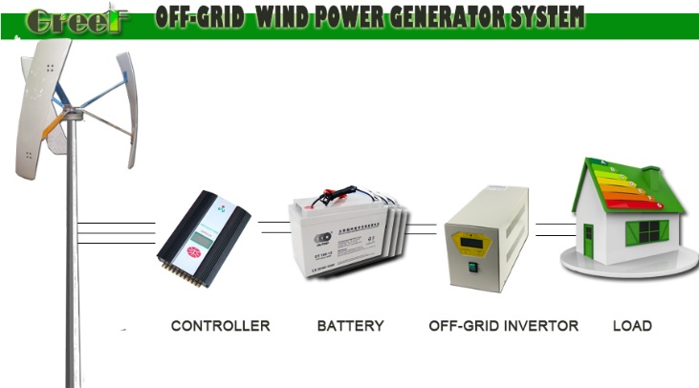
Figure 7: The impression of the off the grind wind power system
However, it is imperative to note that for the home system that has been presented here the single small turbines below 100 kilowatts. The small turbines in the home system will be applied in connection with diesel generators, batteries and the photovoltaic system (Wind Energy Foundation | Wind Power Your Home, 2018). In the case of this house system, the wind will be used in connections with the photovoltaic solar system and the battery system. When wind power is connected to other elements of power generation that have been named here, it is called the hybrid wind system that is in most cases developed off the grid. Hence proposed power turbine system for this house will be a hybrid system.
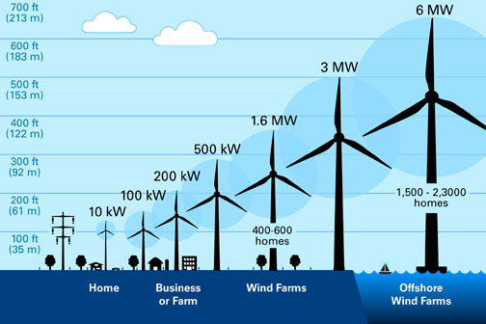
Figure 8: The sizes of the wind turbine and the energy that they are expected to produce. The recommended turbine for home is 400ft in length and has the ability to produce 1.6MW

The house will be powered by a wind system that is known as the distributed wind system. The distributed wind is usually categorized due to the following characteristics such as the location of the plant compared to the end user and power distribution structure rather than the project size or technology size. Two types of infrastructure distributed wind can take. The first infrastructure is called the proximity to the end user where the wind turbines are usually installed at or near the end point of the end-use for the primary purpose of fulfilling the onsite energy demand or supporting the operation of the existing distribution grid. The second infrastructure is known as the point of interconnection infrastructure. In the point of connection infrastructure, the wind turbine is usually connected on the customer's side of the meter. However, since the house, in this case, is off the grid the best system or unit to apply will be the proximity to the end user infrastructure.
The distributed wind energy system has been the type of the turbines that have been in most cases applied to residential areas. However, it is important to note that they have, in some cases, been employed in use for agriculture, commercial purposes and community sites. The home purpose distributed wind system usually range from 5 kilowatts for home purposes and a multi-megawatt turbine that is usually left for the commercial purposes or when connected to a local distribution system
The primary technology type that is used in the distributed wind technology is the small wind turbine technology which usually includes turbines that usually have a rated capacity of less than or equal to 100 Kilowatts
The home system that has been proposed in this case will require small turbine with a 5Kw generating ability to meet all the electricity needs. The turbine that will produce this kind of energy will in most cases provide a diameter of approximately 18 feet. However, the exact turbine that will be needed to power a home will have to range from 2kW to 10kW and will have the length of (12-to 25-foot diameter) based on the home's energy use, the turbine height and the average wind speeds because these are factors that affect the productivity
The off the grid turbine usually have a battery system that can be used to store the energy when the energy that is produced in more than what the house needs. Therefore when the wind blows the electricity from the turbine is usually what is used by the owner of the system. In the case of this house system, the system will be used in conjunction with the photovoltaic technology
Secondary battery The Lithium-Ion battery
The secondary system battery for this house will automatically be off the grind. Therefore it goes without saying that this secondary battery will be powered by the solar panels array or the wind power turbines.

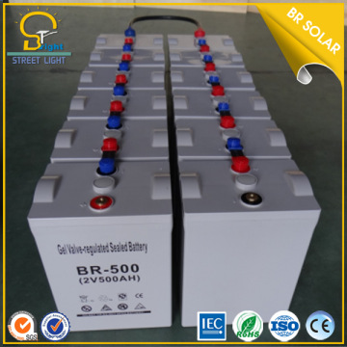
Figure 9: Cells of Lithium ion connected into battery
The secondary battery is essential in this home system because it can be used in instances where there is a power shortage. Determining the battery size that is required in that case becomes very imperative. The battery size will in most cases be determined by the amount of energy that is needed in the house for usage. The house will be secondary battery system will be set to have a time limit for running the battery for one week. The power usage for that period will be estimated to run for 2000 watt power usage. The 2000 watts has been sent becomes it apparent that at night there are chances of more power being used hence the average, in that case, will be at 2000watts. The battery that is used as the secondary battery is usually a group of cells that are wired together sometimes called the battery bank. The lithium energy battery would be the best battery that would be used in that sense because of the large energy density than the lithium battery has for it occupies little space but produces a lot of energy (Hollanda, 2018). The use of the alkaline battery which has lower energy density will mean that then the cell will hold more space.
Merits of Lithium Battery
The lithium battery was recommended for this project due to the merits that were associated with the lithium battery. The initial battery that was used for the solar storage was the lead acid battery. The first merit of the lithium battery is based on the fact that the lithium battery has got very high density- potential that is associated with very high capacities. The lithium battery has also shown very low rate of self-discharge compared to the initial lead acid battery that had crowded the market. The last merit is that lithium battery requires very little maintenance compared to the lead acid battery
Merits of the Lead Acid
The lead acid battery on the other hand were Inexpensive and simple to manufacture — in terms of cost per watt hours, the SLA is the least .Another advantage is that the lead acid technology is a reliable, mature and well understood technology especially when used correctly, the SLA is durable and provides dependable service
Demerits of the Lead Acid
The main demerit of the battery is the fact that it cannot be stored in discharged condition. The lead acid accumulator has very low density that is usually associated in most cases with low storage of energy. The battery will also allow very limited number of full discharge cycles. The lead acid has also been found to be environmentally unfriendly since the electrolyte that has the lead content can cause environmental hazard. There are chances of thermal run away occurring with improper charging.

Fuel cell
The system of power supply that can be used for this housing system is the fuel cell. The primary function of the fuel cell is to convert the chemical potential energy into electrical energy and also heat. For this system of housing, the fuel cell will be highly relevant because the heat that will be produced in the fuel cell generator will be beneficial for the heating of domestic water and driving the refrigeration cycles. In a typical home that that one is shown in these project, the electrical efficiency of the fuel cell will be higher compared to another system. The stationary fuel cell is the units that will be used in this project (Fuel Cells Can Offer Clean and Portable Energy, 2018). These are the units that once installed they cannot be removed. The stable cell fuel will be appropriate for this house because of the power range from 0.5KW-1MW. The technologies that are usually applied when it comes to Fuel cell includes PEMFC, PAFC, MCFC and SOFC.
The phosphoric acid fuel cell will be the fuel cell which will be set for this home's system. These fuel cell may be lower in efficiency for the production of energy, but it is enough to produce the energy that can be used in the house. The process of co-generation can increase productivity. Another important thing about these fuel cell is that it is much cheaper compared to other fuel cells that can be used for the sole purpose of electricity generation.
The phosphoric acid fuel cell is used in stationary power generator that has outputs of up to 100kW to 400kW and efficiently provides the needs of any house system that is off the grid efficiently.
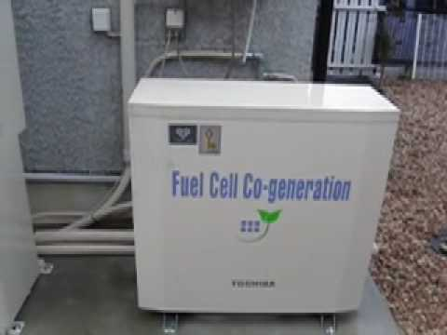
Figure 10: The fuel cell that is best for the house
The merits of the fuel cell
The firs merit of the fuel cell was based on the fact that they have the ability of converting more than 90% of the fuel that is used into energy. The phosphoric acid fuel cells were proved to have the efficiency of 90% a figure that is much higher compared to other energy forms. The fuel cells have the merit of being deployed at the point of supply hence there is no extra cost that is incurred in the process of exportation and the energy loss that might be associated with the same. Another merit of the phosphoric acid fuel cell is that it has very high ability of co-generating heat that comes in addition to electricity production. Due to the fact that they do not have moving parts, fuel cells have higher confidence levels compared to internal combustion engines and combustion turbines. Their use will improve the air quality and reduce water consumption and the waste water discharge. The emission from the fuel cells have been found to be ten times less than the more stringent environmental regulations. Furthermore, fuel cells produce very little carbon dioxide. The nature of operation of fuel cell is advantageous because it allows for the elimination many sources of noise that may be a result of energy production such as by the means of steam. The system of installing the fuel the phosphoric cells can have Flexibility in planning, including modulation, results in financial and strategic benefits to fuel cell units and consumers. Another merit is that the phosphoric fuel cells have the ability of being engineered to operate from the natural gas, gasoline, or other readily obtainable and transported fuels(available at low cost).The fuel cell technology has high potential for development

Switchboard
The switchboard for this system will allow the power system to choose the type of power supply that will be utilized or to move from one kind of amount to another. The solar switchboard in case of this system will be used to determine the energy that is being used between the four types of energy sources that are being used in this house. The switchboard can be identified as a regulator, but it is a very integral part of the house system. The spectra series switchboard will be the best technology to work with when it comes to choosing the switchboards. They can be used for both commercial and domestic application.
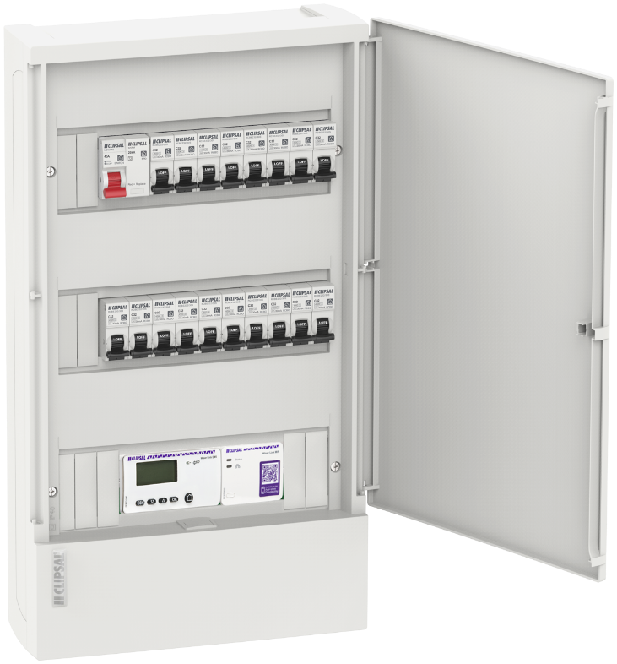
Figure 11: The recommended switchboard for the project

Conclusion
In conclusion, the design of the home power system that has been developed will be using the solar array as the primary source of energy supply while the Fuel cell and the secondary cell will be applied as the last option for supply. It is important to that the energy that has been generated from the turbine will be directly for the storage immediately. Due to the expensive nature of the fuel cell the fuel cell will be only be used on the extreme cases. The power supply that is being provided by the solar array and the wind turbine will be enough to provide the needs for the home

References
Fuel Cells Can Offer Clean and Portable Energy. (2018). Retrieved from https://www.nationalgeographic.com/environment/global-warming/fuel-cells/
Wind Energy Foundation | Wind Power Your Home. (2018). Retrieved from http://windenergyfoundation.org/wind-at-work/wind-consumers/wind-power-your-home/
Maehlum, M. (2018). Grid-Tied, Off-Grid and Hybrid Solar Systems - Energy Informative. Retrieved from http://energyinformative.org/grid-tied-off-grid-and-hybrid-solar-systems/
Hollanday, M. (2018). Batteries for Off-Grid Homes. Retrieved from http://www.greenbuildingadvisor.com/articles/dept/musings/batteries-grid-homes

